**The Legacy Effect of Intensive versus Standard Blood Pressure Control on the Incidence of Mild Cognitive Impairment and Probable Dementia**

David M. Reboussin, PhD

Sarah A. Gaussoin, MS

Nicholas M. Pajewski, PhD

Byron C. Jaeger, PhD

Bonnie C. Sachs, PhD

Stephen R. Rapp, PhD

Mark A. Supiano, MD

Maryjo L. Cleveland, MD

Valerie M. Hunter, MD

Jamehl L. Demons Shegog. MD

Paula Ogrocki, PhD

Alan J. Lerner, MD

Gordon Chelune, PhD

Virginia G. Bradley, PhD

Margaret Scales, MS

Nancy Woolard, MS

Letitia Perdue, MS

Kathryn E. Callahan, MD

Jeff D. Williamson, MD, MHS

Department of Biostatistics and Data Science, Wake Forest School of Medicine, Winston-Salem, North Carolina. (DMR, SAG, BCJ, NMP)

Section on Geriatrics and Gerontologic Medicine, Department of Internal Medicine, Wake Forest University School of Medicine, Winston-Salem, North Carolina. (KEC, JDW)

Division of Geriatrics, University of Utah School of Medicine, Salt Lake City. (MAS)

Department of Neurology, Wake Forest School of Medicine, Winston-Salem, North Carolina. (BCS)

Department of Psychiatry & Behavioral Medicine, Wake Forest University School of Medicine, Winston-Salem, North Carolina. (SRR)

**Correspondence to:**

**PRIMARY RESULTS FROM SPRINT MIND 2020**

**Draft**

**5/28/24**

**INTRODUCTION**

Dementia is a debilitating condition affecting memory and other cognitive functions, behavioral functioning, and social abilities that impair daily life. Prior studies estimate over 9 million Americans could have dementia by 2030 and nearly 12 million by 2040 (1). The prevalence of mild cognitive impairment (MCI), a transitional state between normal cognitive aging and dementia, is also expected to increase. To date, the only intervention demonstrated in a large clinical trial to reduce the risk for MCI is intensive blood pressure (BP) lowering (2).

Hypertension affects more than 50% of persons in the US by the age of 50 years and 75% by age 65 or older (3) and has also been identified as a potentially modifiable risk factor for dementia (4, 5). Cerebrovascular disease underlies vascular cognitive impairment and dementia and is commonly present in Alzheimer’s dementi where it co-occurs with β-amyloid and tau neuropathology (6, 7).

Apart from the earlier SPRINT MIND result, randomized clinical trials of systolic BP (SBP) reductions have not included a follow-up of longer than 4 years linked to expert adjudication of dementia and MCI (8, 9) and no randomized clinical trial of SBP lowering has shown harm at any follow-up duration. Given the rising prevalence of hypertension in middle aged and older adults and the growing personal and societal burden of dementia, long-term results from randomized trials of SBP-lowering therapy may provide valuable evidence to inform healthcare policy.

The Systolic Blood Pressure Intervention Trial (SPRINT) was designed to test the effect of intensive BP control (SBP target <120 mm Hg) versus standard BP control (SBP target < 140 mm Hg) on cardiovascular (primary end point), renal, and cognitive outcomes in persons without diabetes or prior stroke. Results for cardiovascular, renal and adjudicated cognitive impairment for the trial period have been previously reported (2, 10, 11). This article describes the long-term or “legacy” effect of 3.3 years of intensive versus standard BP control on the rate of probable dementia and MCI at a median of 6.9 years.

**METHODS**

**Trial and Extended Follow-up Design**

The main SPRINT trial design and methods have been published previously (2, 10, 12). The extended follow-up reported here was designed to administer a cognitive assessment to participants that were not withdrawn, had not been adjudicated as having probable dementia, and provided informed consent for future research. The study was approved by the institutional review board and participants who were contacted by telephone were asked to provide verbal informed consent. Phone calls began on December 2, 2019 and ended on December 31, 2023.

**Ascertainment of Mild Cognitive Impairment and Probable Dementia**

Procedures for neuropsychological evaluation and expert adjudication of cognitive impairment (MCI and probable dementia) in the SPRINT trial have been previously described (2). While the trial primarily relied on clinic-based in-person neuropsychological assessments, the long-term follow-up data included in the current analysis was collected using centralized telephone follow-up assessments following standardized and validated procedures used in other studies with the same outcomes [(13, 14)]. While telephone assessment of cognitive function has been consistently incorporated in the trial’s ascertainment strategy to accommodate participants that could not complete in-person clinic visits, this form of data collection became standard procedure to allow for continued ascertainment throughout the COVID-19 pandemic. Standardized telephone assessments were administered to participants by trained and certified examiners and included: the Modified Telephone Interview for Cognitive Status (TICS-M) (15); the Hopkins Verbal Learning Test-Revised (16); the Logical Memory test (LM) (17); the Digit Span test (18); Category Fluency-Animals; the Oral Trail Making Test (19); and the 9-item Personal Health Questionnaire (PHQ-9)(20), a measure of depressive symptoms. The Functional Activities Questionnaire (FAQ) (21), a measure of functional status was administered to a knowledgeable proxy by telephone. If a participant had died or was otherwise unable to complete the phone-based cognitive assessment, the Dementia Questionnaire (22), a structured interview assessing observed cognitive and behavioral changes, functional status, and medical and health information was administered to the proxy. For all tests and questionnaires, validated Spanish translations were used when available. Otherwise, instruments were translated by native Spanish speakers and then back-translated.

Adjudication of cognitive status was made by the same panel of experts (neurologists, geriatricians, geropsychiatrists, neuropsychologists and geropsychologists) with clinical expertise diagnosing MCI and dementia that was utilized during the trial period. Adjudication procedures were the same throughout all phases of the trial and follow-up and used all available data collected during each phase, which, in addition to the cognitive assessments and proxy reports, included standardized measures of self-reported perceived health status, quality of life (23), current medications, medical problems, and current health habits (smoking, alcohol use, and physical activity). All references to treatment group were redacted, and the adjudicators were masked to treatment assignment. Participants scoring above 31 on the TICS-M were presumed to have no cognitive impairment; those with scores < 31 were referred for adjudication. Participants were classified into 1 of 3 primary categories: no cognitive impairment, MCI, or probable dementia. Unclassifiable cases (e.g. significant depression, recent health event) were placed in a “cannot classify” category. Each case was reviewed independently by 2 adjudicators using standardized diagnostic criteria for probable dementia and MCI (24, 25). Agreements by the 2 adjudicators were considered final. Disagreements were discussed by the full panel on regularly scheduled conference calls, with the classification decision achieved by a majority vote of the panel members. Additional details of the adjudication process can be found in the protocol (Supplement 1).

**Duration of Follow-up**

The main trial included planned cognitive assessments at baseline and at 2 and 4 years of follow-up, as well as at study closeout if it was more than 1 year removed from the 4-year follow-up visit (eFigure 1 in Supplement 2). The Alzheimer's, Senior and Kidney (SPRINT-ASK) follow-up visit, which included an in-person, or for those unable to attend the clinic visit, a phone-based cognitive assessment, was conducted between October 2017 and July 2018. This analysis included the additional assessments conducted between December 2, 2019, and December 31, 2023.

**Cognitive Outcomes**

The primary cognitive outcome was occurrence of all-cause probable dementia. Secondary cognitive outcomes included occurrence of MCI and a composite outcome of occurrence of either probable dementia or MCI. The occurrence of MCI was defined as 2 or more consecutive adjudicated classifications of MCI (eFigure 2 in Supplement 2).

**Statistical Analysis**

The primary hypothesis was that the rate of all-cause probable dementia would be lower for participants assigned to intensive treatment compared with those assigned to standard treatment over the entire follow-up period. We expected to contact at least half of the eligible cohort, which we estimated would ascertain 651 new cases of probable dementia and provide 90% power for a 17% relative reduction.

Cumulative incidence was estimated for MCI and probable dementia, separately, accounting for the competing risk of death.

[Add initial sentence that says we estimated cumulative incidence curves using an approach that accounts for the competing risk of death]. Treatment group comparisons for were conducted using cause-specific Cox proportional hazards regression models with the baseline hazard function stratified by clinic site. (26, 27) Given the known result that the benefit of intensive treatment on all-cause mortality in SPRINT attenuated over the course of extended follow-up (28), we also fit models that estimated the effect of more intensive SBP lowering as a continuous function of time since randomization (29). Interactions between treatment group and prespecified subgroups were assessed with a likelihood ratio test. We conducted sensitivity analyses accounting for the competing risk of death. We also performed sensitivity analyses to assess the influence of missing data using >details here< (Supplement). All hypothesis tests were 2-sided and performed at the α=.05 level of significance. There was no adjustment of the significance threshold for the secondary or other end points. All analyses were performed using SAS version 9.4 (SAS Institute Inc) and the R statistical computing environment (<http://www.r-project.org>).

Prespecified subgroups included age (<75 vs ≥75 years), sex, race (black vs nonblack), baseline SBP tertiles (≤132, >132 to <145, and ≥145 mm Hg), and presence of CVD, chronic kidney disease, and orthostatic hypotension at baseline.

**RESULTS**

**Study Participants**

Characteristics of the 9361 randomized participants in the main trial design have been published previously (2, 10). Of the 7221 in the cohort who were eligible for this extended follow-up, almost 60%, n=4232, were assessed and had their cognitive status ascertained. The eligible cohort was similar to the full trial cohort (Tables). Blood pressure measurements were not available for this study.

**Follow-up Cognitive Data Collection**

In general, participants who did not complete a cognitive assessment during the extended follow-up were more likely to be non-White, higher baseline SBP, lower eGFR (<60 versus ≥ 60), no baseline aspirin use, had a CVD event during the trial, and did not participate in ASK. 4232 participants completed 1 cognitive assessment; 149 completed 2.

Completion rates decreased at the extended follow-up visits (51% and 49%, respectively, for the intensive and standard treatment groups) but were not statistically different by treatment group (P = .21). Occurrence of indeterminate adjudications (ie, decisions of “cannot classify”) was low and was also similar between the treatment groups (eTable 3 in Supplement 2).

**Primary Cognitive Outcome**

A total of 216 new probable dementia cases were ascertained during this phase of extended follow-up, increasing the total number of PD cases to 541. In the intensive treatment group, a total of 248 participants (8.5 per 1000 person-years) were adjudicated with probable dementia across all stages of follow-up compared with 293 participants (10.2 per 1000 person-years) in the standard treatment group (hazard ratio [HR], 0.86; 95% CI, 0.72-1.02) (Figure and Table). The proportional hazards assumption was tested using Schoenfeld residuals, and was not severely violated, although there was some indication of an increasing difference between the treatment groups during the later observational phase of follow-up (how tested, P = .xx).

There were no significant interactions between treatment group and any prespecified subgroup (Figure ). When death was treated as a competing risk (eFigure 5 in Supplement 2), the results with respect to the effect of intensive treatment on probable dementia were similar (HR, 0.86; 95% CI, 0.73-1.01). [ASK: MODIFY FOR OUR SENSITIVITY ANALYSES Results based on multiple imputation indicated that the incidence of probable dementia was likely underestimated in both treatment groups because of incomplete ascertainment; however, HR estimates were generally unchanged (Supplement).]

**Secondary Cognitive Outcomes**

Two consecutive occurrences of mild cognitive impairment occurred in 380 participants in the intensive treatment group and 430 participants in the standard treatment group (14.0 vs 16.2 per 1000 person-years; HR, 0.87; 95% CI, 0.76-1.00) across all stages of follow-up. There was a significant difference in the composite outcome of MCI or probable dementia favoring the intensive treatment group (20.1 vs 22.9 per 1000 person-years; HR, 0.89; 95% CI, 0.79-0.99). There was a nominally significant interaction between treatment group and presence of chronic kidney disease at baseline with respect to MCI (P = .03) (Supplement); however, this result would not be significant after applying any correction for multiple testing. There were no significant interactions between treatment assignment and prespecified subgroups with respect to the composite of MCI and probable dementia (Supplement).

**DISCUSSION**

This extended follow-up of participants in SPRINT for cognitive status provides important new information about the legacy effect of intensive SBP control on risk for cognitive impairment. These results show that after a median of almost 7 years of extended follow-up, the previously reported statistically significant reduction in the rate of cognitive impairment (composite of MCI or probable dementia) was maintained. The estimated effect on probable dementia, though not statistically significant, was also similar to the primary trial analysis in trending toward a protective effect. These persistent beneficial effects of intensive BP control accruing from additional follow-up are particularly remarkable in that trial participants only underwent an average of 3.3 years of intensive SBP control treatment to a target of less than 120 mm Hg compared with a target of less than 140 mm Hg. These data indicate that intensive BP control can have beneficial effects on cognition for up to 10 years, even if intensive BP control treatment is not maintained for this entire span of time (28).

While SPRINT and several previous trials have shown significant benefit for cardiovascular morbidity and mortality (5, 12)[China Rural Health], there has also emerged a strong body of evidence for intensive BP’s reduction of dementia risk since the original publication of the SPRINT-MIND results [add in ruth peters work and the China rural health He results refs] (30). SM2020 was an extended follow-up study designed to test this same question by further ascertainment of cognitive outcomes in the SPRINT cohort, with a goal of increasing the number of cases of probable dementia enough to provide a robustly powered test of the effect of systolic blood pressure reduction. Additional objectives including confirming the observed effects on MCI and the composite of MCI + PD and exploring whether there might be a long-term (legacy) effect of the blood pressure lowering intervention.

Results from the current study have important potential implications in younger populations. In particular, targeting systolic BP < 120 mm Hg in younger adults may reduce the incidence of PD and MCI substantially.  With as many as 1.7 million dementia cases expected by 2040, a 15% reduction could prevent approximately 25,000 dementia cases over the next 15 years.

Additionally, the persistent protective effect continued for an extended period of time suggesting that BP reduction reduces rates of cognitive impairment not only as long as intensive blood pressure control is maintained, but substantially longer.  As previously reported, the blood pressure difference between the groups rapidly deteriorated to the higher BP goal after the trial ended and the protective impact on cardiovascular and all-cause mortality seen during the trial disappeared during follow-up (REF). Moreover, these results are derived with only 3.3 years of treatment where the standard treatment group achieved a mean SBP of 135 mm Hg. Even with newer guidelines recommending blood pressure treatment to <130 mm Hg (REF), less than 50% of hypertension patients are controlled to level of 140 mm Hg. (REF) This raises the question of what the true magnitude of benefit on cognitive function would be relative to the current poorly controlled systolic blood pressure in most communities.

The results of SPRINT demonstrated the absence of negative impacts on several functional and physiologic outcomes for older adults including reduced cognitive function, reduced brain blood perfusion, increased fall risk, and increased risk of renal failure [refs]. Also, the prevention of mild cognitive impairment, a well-established risk factor for dementia (31) and SPRINT-MIND’s original finding that BP lowering significantly reduces the occurrence of MCI is now supported by other recent trials and meta-analyses with a nearly identical effect sizes (REFS). Nevertheless, some caution should be exercised in interpreting this result, both because MCI was not the primary cognitive outcome of the trial and because the implications of incident MCI for future transition to dementia in SM2020 have not been analyzed. While MCI considerably increases the risk of progression to dementia, reversion to normal cognition is also possible (31) and further analysis in this area is planned.

**Limitations**

This study has several limitations. First, the BP intervention was terminated early because of cardiovascular benefit, resulting in both an attenuation of the SBP difference between the treatment groups and a probable loss of power to detect the full effect of extended BP lowering long term on dementia beyond that point. Second, the trial did not enroll persons with type 2 diabetes, previous stroke, advanced kidney disease, or symptomatic heart failure. Third, the specific choice of thresholds for the MoCA and the Modified Telephone Interview for Cognitive Status to trigger additional testing and adjudication may have underestimated the frequency of MCI; however, there is no indication that such an under-ascertainment was differential by treatment group. Fourth, loss to follow-up, though similar for each treatment group, could have also led to under-ascertainment of outcomes. Fifth, while prevalent dementia was an exclusion criterion for enrollment, the trial did not adjudicate baseline cognitive status; therefore, we cannot exclude or examine the influence of prevalent dementia or MCI at the time of randomization. Sixth, the trial was designed to test 2 different treatment goals and not specific medications; therefore, there is limited ability to discern the relative effect of specific antihypertensive medications on MCI or dementia. Seventh, the use telephone-based cognitive assessment procedures in SPRINT 2020 rather than in-person assessments used in SPRINT was necessary to reach participants in follow-up, but may have introduced a bias. Similar validated procedures have been used in other studies of cognitive impairment (32, 33)Rapp et al, 2012; #13 (Baker et al).

**CONCLUSION**

Among ambulatory adults with hypertension, treating to an SBP goal of less than 120 mm Hg compared with a goal of less than 140 mm Hg results in long term risk reduction (7 years) for MCI alone and MCI plus dementia but not for probable dementia alone. Because of early intensive BP treatment termination, the study may have been underpowered for the full effect on cognitive function and dementia.

**Funding Source.** The work presented here was supported by R01AG055606 and the Alzheimer’s Association. The Systolic Blood Pressure Intervention Trial was funded by the National Institutes of Health (including the National Heart, Lung, and Blood Institute, the National Institute of Diabetes and Digestive and Kidney Diseases, the National Institute on Aging, and the National Institute of Neurological Disorders and Stroke) under contracts HHSN268200900040C, HHSN268200900046C, HHSN268200900047C, HHSN268200900048C, and HHSN268200900049C and interagency agreement A-HL-13-002-001. It was also supported in part with resources and use of facilities through the Department of Veterans Affairs. Azilsartan and chlorthalidone (combined with azilsartan) were provided by Takeda Pharmaceuticals International Inc.

Additional support was provided through the following National Center for Advancing Translational Sciences clinical and translational science awards: UL1TR000439 (awarded to Case Western Reserve University); UL1RR025755 (Ohio State University); UL1RR024134 and UL1TR000003 (University of Pennsylvania); UL1RR025771 (Boston University); UL1TR000093 (Stanford University); UL1RR025752, UL1TR000073, and UL1TR001064 (Tufts University); UL1TR000050 (University of Illinois); UL1TR000005 (University of Pittsburgh); U54TR000017-06 (University of Texas Southwestern Medical Center); UL1TR000105-05 (University of Utah); UL1 TR000445 (Vanderbilt University); UL1TR000075 (George Washington University); UL1 TR000002 (University of California, Davis); UL1 TR000064 (University of Florida); and UL1TR000433 (University of Michigan); and by National Institute of General Medical Sciences, Centers of Biomedical Research Excellence award NIGMS P30GM103337 (awarded to Tulane University).

**IRB Approval.** The Systolic Blood Pressure Intervention Trial was approved by the institutional review board at each participating site, and each participant provided written informed consent.

**Acknowledgement.** The views expressed in this paper are those of the authors and do not represent the official position of the National Institutes of Health (NIH), the National Heart, Lung, and Blood Institute, the Department of Veterans Affairs, the U.S. Government, the Alzheimer’s Association, or the SPRINT Research Group. This paper was not reviewed by the SPRINT Publications and Presentations Committee.

**REFERENCES**

1. Association As. 2023 Alzheimer's disease facts and figures. Alzheimers Dement. 2023;19(4):1598-695.

2. Group SMIftSR, Williamson JD, Pajewski NM, Auchus AP, Bryan RN, Chelune G, et al. Effect of Intensive vs Standard Blood Pressure Control on Probable Dementia: A Randomized Clinical Trial. JAMA. 2019;321(6):553-61.

3. Muntner P, Hardy ST, Fine LJ, Jaeger BC, Wozniak G, Levitan EB, et al. Trends in Blood Pressure Control Among US Adults With Hypertension, 1999-2000 to 2017-2018. JAMA. 2020;324(12):1190-200.

4. Palta P, Albert MS, Gottesman RF. Heart health meets cognitive health: evidence on the role of blood pressure. Lancet Neurol. 2021;20(10):854-67.

5. Williamson JD, Supiano MA, Applegate WB, Berlowitz DR, Campbell RC, Chertow GM, et al. Intensive vs Standard Blood Pressure Control and Cardiovascular Disease Outcomes in Adults Aged >/=75 Years: A Randomized Clinical Trial. JAMA. 2016;315(24):2673-82.

6. Sweeney MD, Montagne A, Sagare AP, Nation DA, Schneider LS, Chui HC, et al. Vascular dysfunction-The disregarded partner of Alzheimer's disease. Alzheimers Dement. 2019;15(1):158-67.

7. Iadecola C, Duering M, Hachinski V, Joutel A, Pendlebury ST, Schneider JA, et al. Vascular Cognitive Impairment and Dementia: JACC Scientific Expert Panel. J Am Coll Cardiol. 2019;73(25):3326-44.

8. Elias MF, Torres RV, Davey A. Clinical Trials of Blood Pressure Lowering and Antihypertensive Medication: Is Cognitive Measurement State-of-the-Art? Am J Hypertens. 2018;31(6):631-42.

9. Rouch L, Cestac P, Hanon O, Cool C, Helmer C, Bouhanick B, et al. Antihypertensive Drugs, Prevention of Cognitive Decline and Dementia: A Systematic Review of Observational Studies, Randomized Controlled Trials and Meta-Analyses, with Discussion of Potential Mechanisms. Cns Drugs. 2015;29(2):113-30.

10. Group SR, Wright JT, Jr., Williamson JD, Whelton PK, Snyder JK, Sink KM, et al. A Randomized Trial of Intensive versus Standard Blood-Pressure Control. N Engl J Med. 2015;373(22):2103-16.

11. Rapp SR, Gaussoin SA, Sachs BC, Chelune G, Supiano MA, Lerner AJ, et al. Effects of intensive versus standard blood pressure control on domain-specific cognitive function: a substudy of the SPRINT randomised controlled trial. Lancet Neurol. 2020;19(11):899-907.

12. Ambrosius WT, Sink KM, Foy CG, Berlowitz DR, Cheung AK, Cushman WC, et al. The design and rationale of a multicenter clinical trial comparing two strategies for control of systolic blood pressure: The Systolic Blood Pressure Intervention Trial (SPRINT). Clin Trials. 2014;11(5):532-46.

13. Baker LD, Manson JE, Rapp SR, Sesso HD, Gaussoin SA, Shumaker SA, et al. Effects of cocoa extract and a multivitamin on cognitive function: A randomized clinical trial. Alzheimer's & Dementia. 2023;19(4):1308-19.

14. Baker LD, Rapp SR, Shumaker SA, Manson JE, Sesso HD, Gaussoin SA, et al. Design and baseline characteristics of the cocoa supplement and Check fa multivitamin outcomes study for the Mind: COSMOS-Mind. Contemp Clin Trials. 2019;83:57-63.

15. Welsh KA, Breitner JCS, Magruderhabib KM. Detection of Dementia in the Elderly Using Telephone Screening of Cognitive Status. Neuropsy Neuropsy Be. 1993;6(2):103-10.

16. Brandt J. The Hopkins Verbal Learning Test. Clinical Neuropsychologist. 1991;5:125-42.

17. Wechsler D. Wechsler Memory Scale. 4th ed. San Antonio TX: Pearson; 2009.

18. Wechsler D. Wechsler Adult Intelligence Scale. 4th ed. San Antonio TX: Pearson; 2008.

19. Ricker JH, Axelrod BN, Houtler BD. Clinical validation of the oral trail making test. Neuropsy Neuropsy Be. 1996;9(1):50-3.

20. Spitzer RL, Williams JB, Kroenke K, Linzer M, deGruy FV, 3rd, Hahn SR, et al. Utility of a new procedure for diagnosing mental disorders in primary care. The PRIME-MD 1000 study. JAMA. 1994;272(22):1749-56.

21. Pfeffer RI, Kurosaki TT, Harrah CH, Chance JM, Filos S. Measurement of Functional Activities in Older Adults in the Community. J Gerontol. 1982;37(3):323-9.

22. Kawas C, Segal J, Stewart WF, Corrada M, Thai LJ. A Validation-Study of the Dementia Questionnaire. Arch Neurol-Chicago. 1994;51(9):901-6.

23. Berlowitz DR, Foy CG, Kazis LE, Bolin LP, Conroy MB, Fitzpatrick P, et al. Effect of Intensive Blood-Pressure Treatment on Patient-Reported Outcomes. N Engl J Med. 2017;377(8):733-44.

24. Albert MS, DeKosky ST, Dickson D, Dubois B, Feldman HH, Fox NC, et al. The diagnosis of mild cognitive impairment due to Alzheimer's disease: Recommendations from the National Institute on Aging-Alzheimer's Association workgroups on diagnostic guidelines for Alzheimer's disease. Alzheimers Dement. 2011;7(3):270-9.

25. McKhann GM, Knopman DS, Chertkow H, Hyman BT, Jack CR, Kawas CH, et al. The diagnosis of dementia due to Alzheimer's disease: Recommendations from the National Institute on Aging-Alzheimer's Association workgroups on diagnostic guidelines for Alzheimer's disease. Alzheimers Dement. 2011;7(3):263-9.

26. Austin PC, Fine JP. Accounting for competing risks in randomized controlled trials: a review and recommendations for improvement. Stat Med. 2017;36(8):1203-9.

27. Glidden DV, Vittinghoff E. Modelling clustered survival data from multicentre clinical trials. Stat Med. 2004;23(3):369-88.

28. Jaeger BC, Bress AP, Bundy JD, Cheung AK, Cushman WC, Drawz PE, et al. Longer-Term All-Cause and Cardiovascular Mortality With Intensive Blood Pressure Control: A Secondary Analysis of a Randomized Clinical Trial. JAMA Cardiol. 2022;7(11):1138-46.

29. Therneau TMC, C; Atkinson, E. Using time dependent covariates and time dependent coefficients in the Cox model2024. Available from: <https://cran.r-project.org/web/packages/survival/> vignettes/timedep.pdf.

30. Hughes D, Judge C, Murphy R, Loughlin E, Costello M, Whiteley W, et al. Association of Blood Pressure Lowering With Incident Dementia or Cognitive Impairment: A Systematic Review and Meta-analysis. JAMA. 2020;323(19):1934-44.

31. Petersen RC, Lopez O, Armstrong MJ, Getchius TSD, Ganguli M, Gloss D, et al. Practice guideline update summary: Mild cognitive impairment: Report of the Guideline Development, Dissemination, and Implementation Subcommittee of the American Academy of Neurology. Neurology. 2018;90(3):126-35.

32. Gierzynski TF, Gregoire A, Reader JM, Pantis R, Campbell S, Bhaumik A, et al. Evaluation of the Uniform Data Set version 3 teleneuropsychological measures. J Int Neuropsychol Soc. 2024;30(2):183-93.

33. Sachs BC, Latham LA, Bateman JR, Cleveland MJ, Espeland MA, Fischer E, et al. Feasibility of Remote Administration of the Uniform Data Set-Version 3 for Assessment of Older Adults With Mild Cognitive Impairment and Alzheimer's Disease. Arch Clin Neuropsychol. 2024.

Tables and Figures

Table 1. Outcomes by Study Phase

|  |  |  |  |
| --- | --- | --- | --- |
| Adjudicated Outcome | SPRINT | SM2020 | SM2023 |
| PD | 325 | 525 | 541 |
| Protocol MCI | 640 | 749 | 810 |
| PD/Protocol MCI | 871 | 1116 | 1177 |

Table 2. Incidence of Probable Dementia and Mild Cognitive Impairment by Treatment Group

|  | Intensive | | Standard | |  | |
| --- | --- | --- | --- | --- | --- | --- |
| Outcomes | No. With Outcome/Person-Years | Cases per 1000 Person-Years | No. With Outcome/Person-Years | Cases per 1000 Person-Years | Hazard Ratio  (95% Confidence Interval) | P-Value |
| Probable Dementia | 248/29128 | 8.5 | 293/28866 | 10.2 | 0.86 (0.72, 1.02) | 0.0801 |
| Mild Cognitive Impairment (Two consecutive) | 380/27155 | 14.0 | 430/26526 | 16.2 | 0.87 (0.76, 1.00) | 0.0435 |
| Probable Dementia or Mild Cognitive Impairment (Two consecutive) | 555/27628 | 20.1 | 622/27122 | 22.9 | 0.89 (0.79, 0.99) | 0.0402 |

*PD treating death as a competing risk HR: 0.86 (0.73, 1.01) p-value=0.06

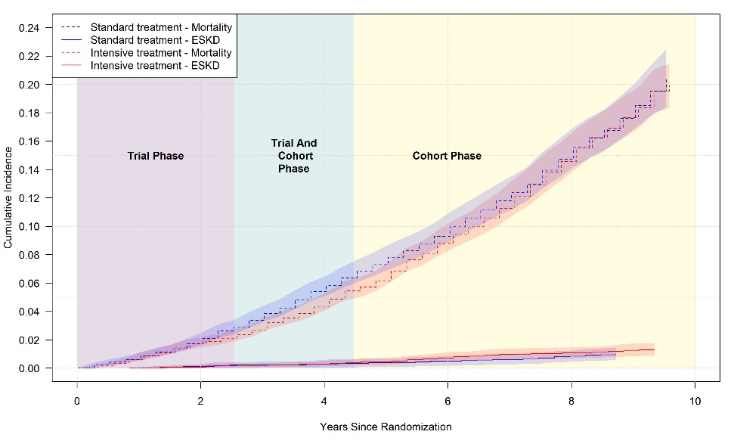

**Figure:** Probable dementia

**Figure:** Mild cognitive impairment

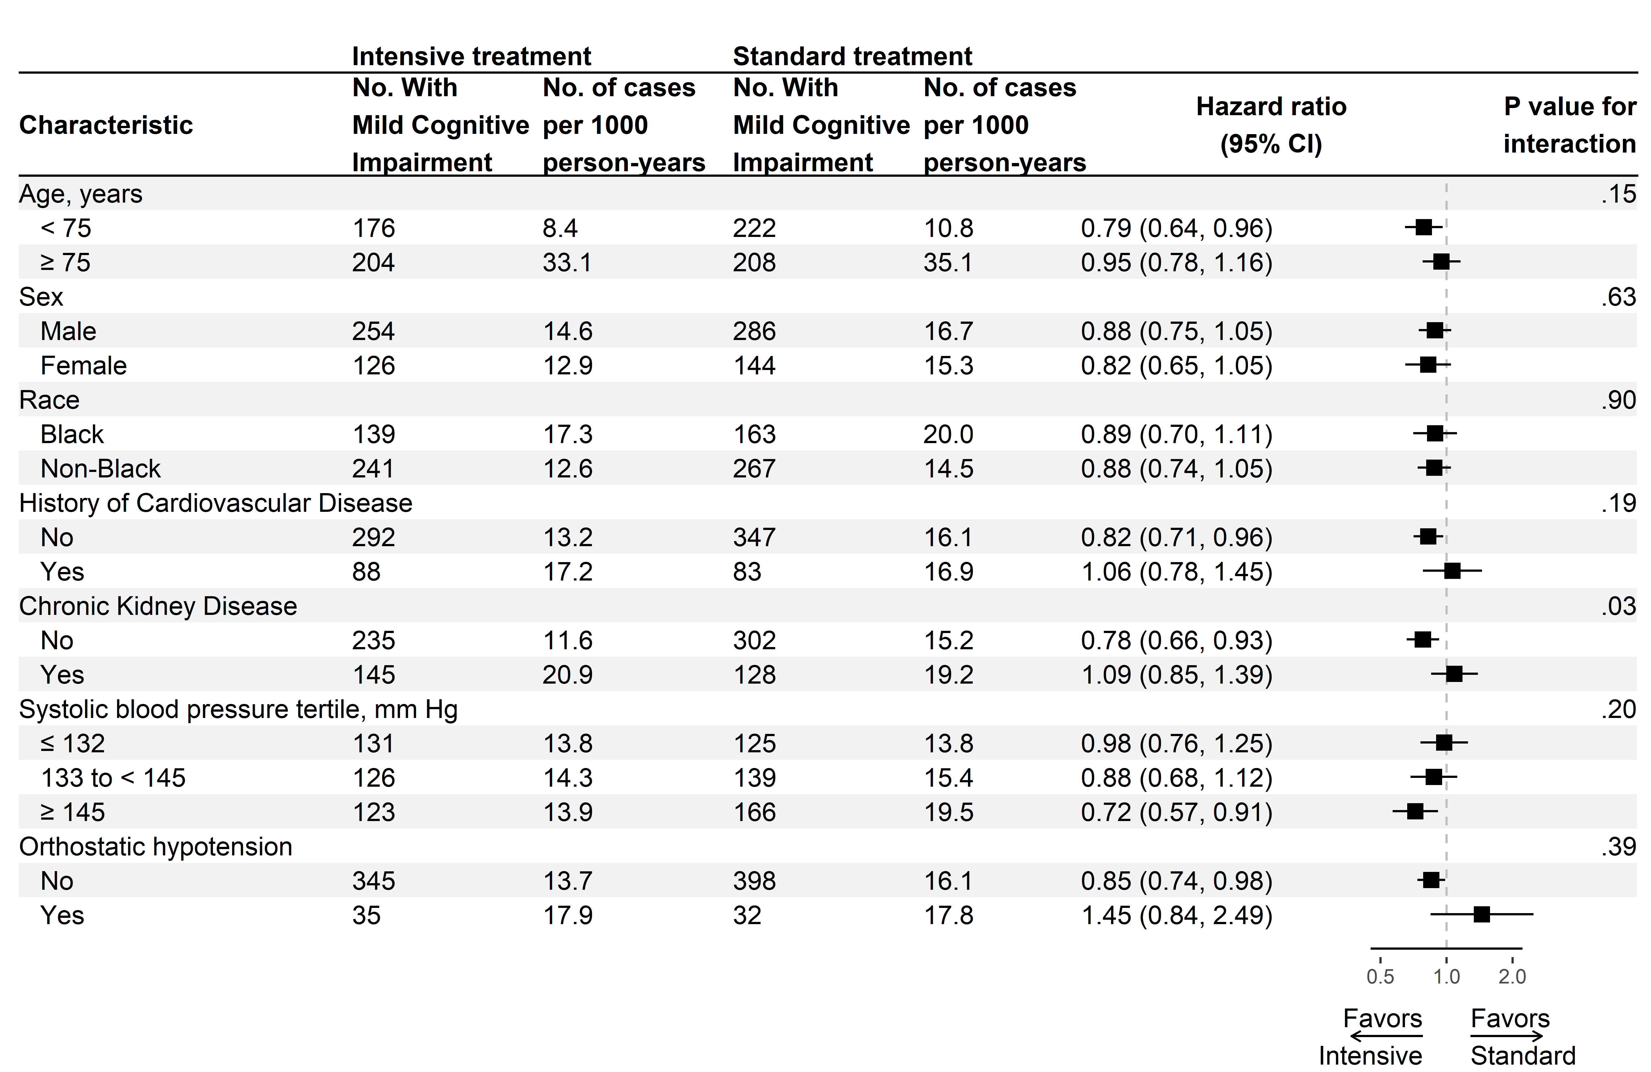

**Figure:** Composite outcome of probable dementia or mild cognitive impairment

Table. SM2020 Data Completion by Variables of Interest

|  | ***SM2020 Assessment Missing (N=2988)*** | ***SM2020 Assessment Completed (N=4232)*** | ***Overall (N=7220)*** | ***P-value*** |
| --- | --- | --- | --- | --- |
| **Randomized to intensive treatment, No. (%)** | **1480 (49.5)** | **2160 (51.0)** | **3640 (50.4)** | **0.2068** |
| **Age, y** |  |  |  |  |
| **Mean (SD), years** | **67.29 (9.26)** | **67.42 (8.84)** | **67.37 (9.02)** | **0.5290** |
| **Age 75 years or older, No. (%)** | **780 (26.1)** | **1037 (24.5)** | **1817 (25.2)** | **0.1227** |
| **Female sex, No. (%)** | **985 (33.0)** | **1530 (36.2)** | **2515 (34.8)** | **0.0051** |
| **Race/Ethnicity, No. (%)** |  |  |  | **<.0001** |
| **BLACK** | **977 (32.7)** | **1149 (27.2)** | **2126 (29.4)** |  |
| **HISPANIC** | **371 (12.4)** | **351 (8.3)** | **722 (10.0)** |  |
| **OTHER** | **56 (1.9)** | **74 (1.7)** | **130 (1.8)** |  |
| **WHITE** | **1584 (53.0)** | **2658 (62.8)** | **4242 (58.8)** |  |
| **Seated blood pressure, mean (SD), mm HG** |  |  |  |  |
| **Systolic** | **140.0 (15.6)** | **138.8 (15.1)** | **139.3 (15.3)** | **0.0010** |
| **Diastolic** | **78.6 (11.9)** | **78.3 (11.6)** | **78.4 (11.8)** | **0.2893** |
| **Orthostatic hypotension, No. (%)** | **208 (7.0)** | **297 (7.0)** | **505 (7.0)** | **0.9258** |
| **History of cardiovascular disease, No. (%)** | **603 (20.2)** | **783 (18.5)** | **1386 (19.2)** | **0.0744** |
| **Estimated GFR, mean (SD), mL/min/1.73 m2** | **72.35 (21.53)** | **72.70 (19.26)** | **72.55 (20.23)** | **0.4706** |
| **Estimated GFR<60 ml/min/1.73 m2, No. (%)** | **853 (28.6)** | **1049 (24.9)** | **1902 (26.4)** | **0.0004** |
| **Urinary albumin to creatinine ratio, mg/g, median (IQR)** | **9.35 (5.76, 21.34)** | **8.87 (5.41, 18.70)** | **9.09 (5.56, 19.70)** |  |
| **Total cholesterol, mean (SD), mg/dl** | **191.14 (42.79)** | **189.78 (40.44)** | **190.34 (41.43)** | **0.1700** |
| **HDL cholesterol, mean (SD), mg/dl** | **52.57 (14.66)** | **52.69 (13.89)** | **52.64 (14.21)** | **0.7194** |
| **Triglycerides, median (IQR), mg/dl** | **108.00 (78.00, 153.00)** | **107.00 (77.00, 150.00)** | **107.00 (77.00, 151.00)** |  |
| **Glucose, mean (SD), mg/dl** | **98.94 (13.40)** | **98.95 (13.20)** | **98.94 (13.28)** | **0.9765** |
| **Statin use, No. (%)** | **1289 (43.4)** | **1831 (43.5)** | **3120 (43.5)** | **0.9015** |
| **Aspirin use, No. (%)** | **1459 (48.9)** | **2228 (52.8)** | **3687 (51.2)** | **0.0012** |
| **10-y Framingham cardiovascular disease risk, median (IQR), %** | **22.75 (16.02, 32.50)** | **21.09 (14.80, 30.02)** | **21.84 (15.17, 31.06)** |  |
| **BMI, mean (SD), mg/dl** | **30.12 (5.70)** | **30.01 (5.81)** | **30.05 (5.77)** | **0.4297** |
| **CVD Event, No. (%)** | **194 (6.5)** | **219 (5.2)** | **413 (5.7)** | **0.0176** |
| **CKD Event, No. (%)** | **82 (2.7)** | **106 (2.5)** | **188 (2.6)** | **0.5289** |
| **ASK Participant, No. (%)** |  |  |  | **<.0001** |
| **No** | **1809 (60.5)** | **1648 (38.9)** | **3457 (47.9)** |  |
| **Yes** | **1179 (39.5)** | **2584 (61.1)** | **3763 (52.1)** |  |
| **Network, No. (%)** |  |  |  | **<.0001** |
| **1 - Ohio CCN** | **517 (17.3)** | **729 (17.2)** | **1246 (17.3)** |  |
| **2 - Southeast CCN** | **593 (19.8)** | **975 (23.0)** | **1568 (21.7)** |  |
| **3 - Utah CCN** | **613 (20.5)** | **1004 (23.7)** | **1617 (22.4)** |  |
| **4 - UAB CCN** | **653 (21.9)** | **851 (20.1)** | **1504 (20.8)** |  |
| **5 - VAMC CCN** | **612 (20.5)** | **673 (15.9)** | **1285 (17.8)** |  |

Table. SM2020 Data Completion For Deceased Participants by Variables of Interest

|  | ***SM2020 Assessment Missing (N=608)*** | ***SM2020 Assessment Completed (N=450)*** | ***Overall***  ***Deceased (N=1058)*** | ***P-value*** |
| --- | --- | --- | --- | --- |
| **Randomized to intensive treatment, No. (%)** | **314 (51.6)** | **230 (51.1)** | **544 (51.4)** | **0.8637** |
| **Age, y** |  |  |  |  |
| **Mean (SD), years** | **72.00 (9.77)** | **74.56 (9.17)** | **73.09 (9.60)** | **<.0001** |
| **Age 75 years or older, No. (%)** | **291 (47.9)** | **249 (55.3)** | **540 (51.0)** | **0.0162** |
| **Female sex, No. (%)** | **193 (31.7)** | **132 (29.3)** | **325 (30.7)** | **0.4008** |
| **Race/Ethnicity, No. (%)** |  |  |  | **<.0001** |
| **BLACK** | **192 (31.6)** | **81 (18.0)** | **273 (25.8)** |  |
| **HISPANIC** | **36 (5.9)** | **13 (2.9)** | **49 (4.6)** |  |
| **OTHER** | **9 (1.5)** | **4 (0.9)** | **13 (1.2)** |  |
| **WHITE** | **371 (61.0)** | **352 (78.2)** | **723 (68.3)** |  |
| **Seated blood pressure, mean (SD), mm HG** |  |  |  |  |
| **Systolic** | **140.9 (15.8)** | **141.0 (15.4)** | **141.0 (15.6)** | **0.9552** |
| **Diastolic** | **75.8 (12.6)** | **74.9 (12.7)** | **75.4 (12.7)** | **0.2634** |
| **Orthostatic hypotension, No. (%)** | **60 (9.9)** | **45 (10.0)** | **105 (9.9)** | **0.9436** |
| **History of cardiovascular disease, No. (%)** | **181 (29.8)** | **131 (29.1)** | **312 (29.5)** | **0.8163** |
| **Estimated GFR, mean (SD), mL/min/1.73 m2** | **67.52 (23.77)** | **64.87 (19.73)** | **66.40 (22.18)** | **0.0546** |
| **Estimated GFR<60 ml/min/1.73 m2, No. (%)** | **252 (41.4)** | **189 (42.3)** | **441 (41.8)** | **0.7860** |
| **Urinary albumin to creatinine ratio, mg/g, median (IQR)** | **13.66 (7.14, 40.74)** | **14.97 (6.95, 43.10)** | **14.06 (7.08, 42.38)** |  |
| **Total cholesterol, mean (SD), mg/dl** | **183.71 (42.66)** | **181.41 (40.78)** | **182.73 (41.87)** | **0.3759** |
| **HDL cholesterol, mean (SD), mg/dl** | **53.66 (15.90)** | **54.08 (14.68)** | **53.84 (15.39)** | **0.6598** |
| **Triglycerides, median (IQR), mg/dl** | **97.00 (73.00, 138.50)** | **98.00 (72.00, 134.00)** | **97.00 (73.00, 136.00)** |  |
| **Glucose, mean (SD), mg/dl** | **98.21 (13.90)** | **98.12 (13.27)** | **98.18 (13.63)** | **0.9179** |
| **Statin use, No. (%)** | **287 (47.5)** | **214 (48.1)** | **501 (47.8)** | **0.8542** |
| **Aspirin use, No. (%)** | **329 (54.3)** | **272 (60.6)** | **601 (57.0)** | **0.0414** |
| **10-y Framingham cardiovascular disease risk, median (IQR), %** | **28.03 (18.85, 38.51)** | **28.55 (19.75, 39.03)** | **28.27 (19.37, 38.87)** |  |
| **BMI, mean (SD), mg/dl** | **29.53 (5.97)** | **28.43 (6.01)** | **29.06 (6.01)** | **0.0035** |
| **CVD Event, No. (%)** | **69 (11.3)** | **61 (13.6)** | **130 (12.3)** | **0.2797** |
| **CKD Event, No. (%)** | **25 (4.1)** | **18 (4.0)** | **43 (4.1)** | **0.9274** |
| **ASK Participant, No. (%)** |  |  |  | **0.0017** |
| **No** | **430 (70.7)** | **277 (61.6)** | **707 (66.8)** |  |
| **Yes** | **178 (29.3)** | **173 (38.4)** | **351 (33.2)** |  |
| **Network, No. (%)** |  |  |  | **<.0001** |
| **1 - Ohio CCN** | **517 (17.3)** | **729 (17.2)** | **1246 (17.3)** |  |
| **2 - Southeast CCN** | **593 (19.8)** | **975 (23.0)** | **1568 (21.7)** |  |
| **3 - Utah CCN** | **613 (20.5)** | **1004 (23.7)** | **1617 (22.4)** |  |
| **4 - UAB CCN** | **653 (21.9)** | **851 (20.1)** | **1504 (20.8)** |  |
| **5 - VAMC CCN** | **612 (20.5)** | **673 (15.9)** | **1285 (17.8)** |  |

**Figure:** Timeline for follow-up in the Systolic Blood Pressure Intervention Trial

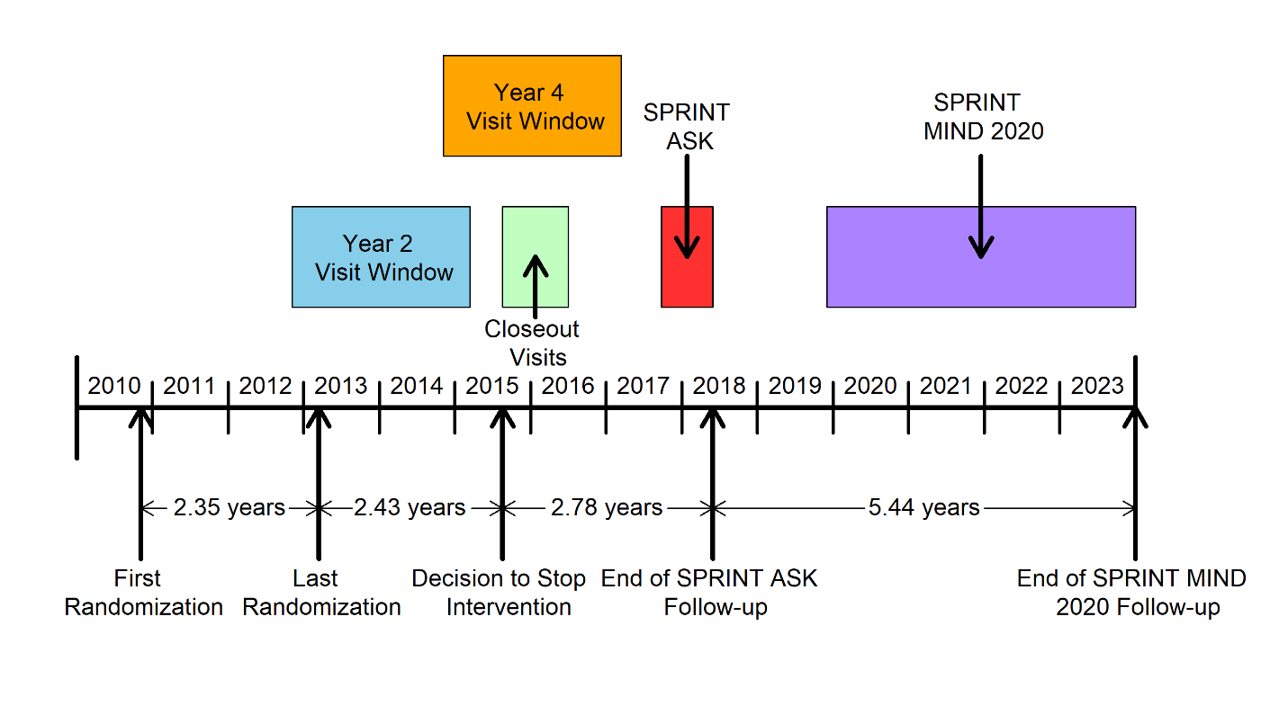

**Figure:** CONSORT diagram

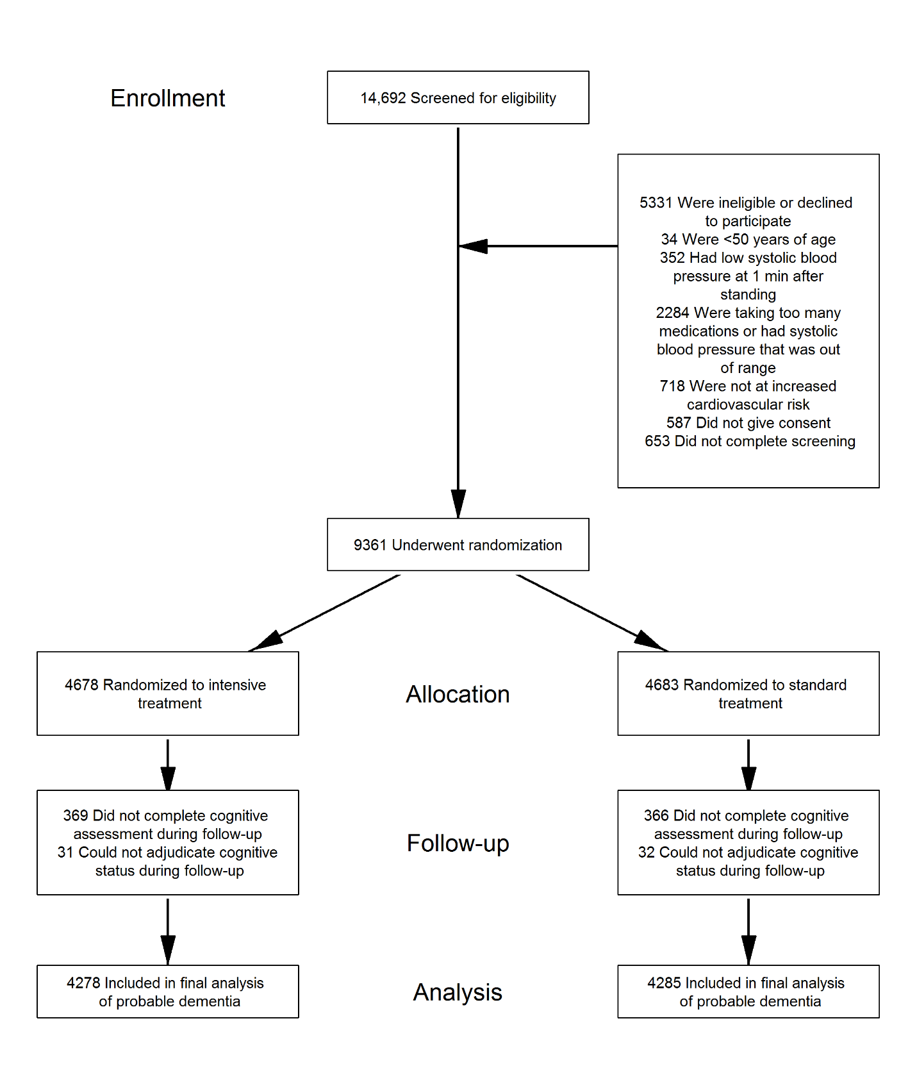

**Figure:** Probable dementia censoring

**Figure:** Probable dementia status

**Figure:** Mild cognitive impairment censoring

**Figure:** Mild cognitive impairment status

